Organic Chemical Diversity Beyond Earth:
C-, N-, S- and P-cycling from Earth to other parent bodies
Schmitt-Kopplin Ph.^{1, 2, 3}
¹Technical University Munich TUM, analytical Food Chemistry, Weihenstephan, Freising, Germany,
²Helmholtz Munich, analytical BioGeoChemistry, Oberschleißheim, Germany,
³Max Plank Institute for Extraterrestrial Physics, Center for Astrochemical Studies, Garching, Germany
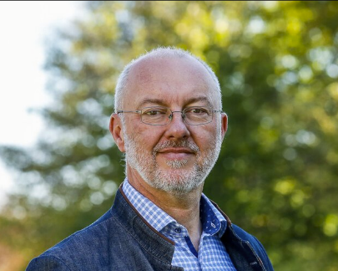
(schmitt-kopplin@tum.de)

Abstract:
Understanding complex organic mixtures in bio- and geosystems at the molecular level remains a major challenge in modern science. From an analytical chemistry perspective, this endeavor demands the continuous development of high-resolution analytical technologies and innovative approaches for advanced data interpretation.
Our goal is to reveal the chemical diversity and complexity of organic natural mixtures shaped by both biotic and abiotic processes. We present conceptual frameworks and experimental results that illustrate the breadth of chemical complexity across diverse systems—from life (Metabolomics), to post-life (Organic Geochemistry in water systems), towards pre-life stages (Astrochemistry). These interconnected domains highlight the analytical challenges in characterizing dynamic molecular systems.
Examples and applications are drawn from ongoing projects, including studies profiling the chemistry within the terrestrial biogeochemical continuum in water systems and investigations of extraterrestrial environments. We emphasize the role of non-enzymatic processes in linking and regulating chemistry across these super-systems. Particular attention is given to the carbon, sulfur, nitrogen and phosphorous chemistry in meteorites, providing insights into abiotic parent-body processes. These concepts and findings are essentials to interpret data from sample-return missions such as HAYABUSA2 and OSIRIS-REx, which delivered CHNOPS material from the asteroids Ryugu and Bennu in collaboration with JAXA and NASA.

